МИНИСТЕРСТВО ОБРАЗОВАНИЯ РЕСПУБЛИКИ БЕЛАРУСЬ

УЧРЕЖДЕНИЕ ОБРАЗОВАНИЯ

“БРЕСТСКИЙ ГОСУДАРСТВЕННЫЙ ТЕХНИЧЕСКИЙ УНИВЕРСИТЕТ”

**ИНТЕЛЕКТУАЛЬНЫЕ ИНФОРМАЦИОННЫЕ ТЕХНОЛОГИИ**

ОТЧЁТ

По лабораторной работе № 4

Выполнил:

Студент группы ИИ-22

Копанчук Е. Р.

Проверил:

Касьяник В.В.

Брест – 2023

**Ход работы**

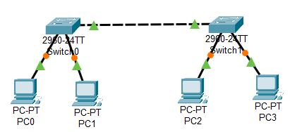

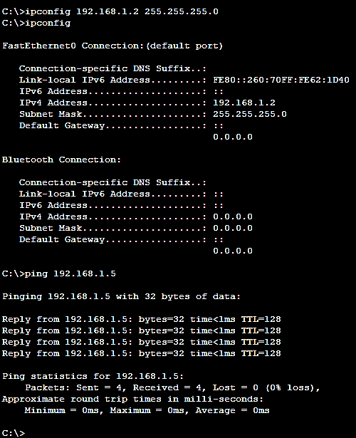

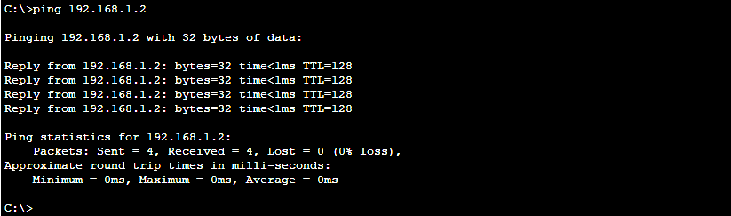

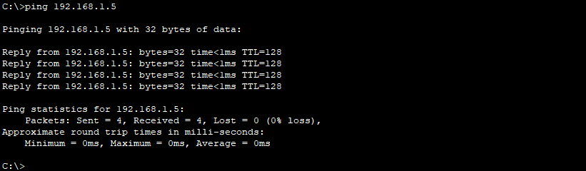

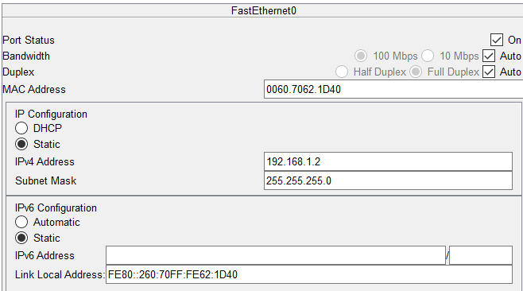

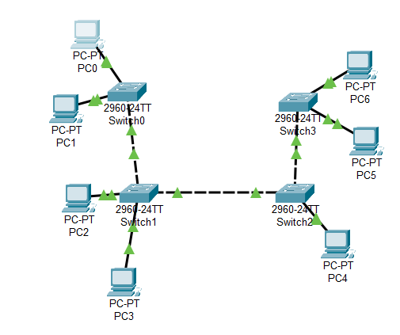

|  |  |
| --- | --- |
| Pinging 8.1.1.1 with 32 bytes of data:  Reply from 8.1.1.1: bytes=32 time=10ms TTL=128  Reply from 8.1.1.1: bytes=32 time=1ms TTL=128  Reply from 8.1.1.1: bytes=32 time<1ms TTL=128  Reply from 8.1.1.1: bytes=32 time=4ms TTL=128  Ping statistics for 8.1.1.1:  Packets: Sent = 4, Received = 4, Lost = 0 (0% loss),  Approximate round trip times in milli-seconds:  Minimum = 0ms, Maximum = 10ms, Average = 3ms  C:\>ping 8.1.1.2  Pinging 8.1.1.2 with 32 bytes of data:  Reply from 8.1.1.2: bytes=32 time<1ms TTL=128  Reply from 8.1.1.2: bytes=32 time<1ms TTL=128  Reply from 8.1.1.2: bytes=32 time<1ms TTL=128  Reply from 8.1.1.2: bytes=32 time<1ms TTL=128  Ping statistics for 8.1.1.2:  Packets: Sent = 4, Received = 4, Lost = 0 (0% loss),  Approximate round trip times in milli-seconds:  Minimum = 0ms, Maximum = 0ms, Average = 0ms  C:\>ping 8.1.1.3  Pinging 8.1.1.3 with 32 bytes of data:  Reply from 8.1.1.3: bytes=32 time<1ms TTL=128  Reply from 8.1.1.3: bytes=32 time<1ms TTL=128  Reply from 8.1.1.3: bytes=32 time<1ms TTL=128  Reply from 8.1.1.3: bytes=32 time<1ms TTL=128  Ping statistics for 8.1.1.3:  Packets: Sent = 4, Received = 4, Lost = 0 (0% loss),  Approximate round trip times in milli-seconds:  Minimum = 0ms, Maximum = 0ms, Average = 0msС  С:\>ping 8.1.1.4  Pinging 8.1.1.4 with 32 bytes of data:  Reply from 8.1.1.4: bytes=32 time<1ms TTL=128  Reply from 8.1.1.4: bytes=32 time<1ms TTL=128  Reply from 8.1.1.4: bytes=32 time<1ms TTL=128  Reply from 8.1.1.4: bytes=32 time<1ms TTL=128  Ping statistics for 8.1.1.4:  Packets: Sent = 4, Received = 4, Lost = 0 (0% loss),  Approximate round trip times in milli-seconds:  Minimum = 0ms, Maximum = 0ms, Average = 0ms | C:\>ping 8.1.1.5  Pinging 8.1.1.5 with 32 bytes of data:  Reply from 8.1.1.5: bytes=32 time<1ms TTL=128  Reply from 8.1.1.5: bytes=32 time<1ms TTL=128  Reply from 8.1.1.5: bytes=32 time<1ms TTL=128  Reply from 8.1.1.5: bytes=32 time=1ms TTL=128  Ping statistics for 8.1.1.5:  Packets: Sent = 4, Received = 4, Lost = 0 (0% loss),  Approximate round trip times in milli-seconds:  Minimum = 0ms, Maximum = 1ms, Average = 0ms  C:\>ping 8.1.1.6  Pinging 8.1.1.6 with 32 bytes of data:  Reply from 8.1.1.6: bytes=32 time<1ms TTL=128  Reply from 8.1.1.6: bytes=32 time<1ms TTL=128  Reply from 8.1.1.6: bytes=32 time<1ms TTL=128  Reply from 8.1.1.6: bytes=32 time<1ms TTL=128  Ping statistics for 8.1.1.6:  Packets: Sent = 4, Received = 4, Lost = 0 (0% loss),  Approximate round trip times in milli-seconds:  Minimum = 0ms, Maximum = 0ms, Average = 0ms  C:\>ping 8.1.1.7  Pinging 8.1.1.7 with 32 bytes of data:  Reply from 8.1.1.7: bytes=32 time<1ms TTL=128  Reply from 8.1.1.7: bytes=32 time<1ms TTL=128  Reply from 8.1.1.7: bytes=32 time<1ms TTL=128  Reply from 8.1.1.7: bytes=32 time<1ms TTL=128  Ping statistics for 8.1.1.7:  Packets: Sent = 4, Received = 4, Lost = 0 (0% loss),  Approximate round trip times in milli-seconds:  Minimum = 0ms, Maximum = 0ms, Average = 0ms  C:\> |

